**Product-wise Sales Comparison Report  
02 August 2025  
Prepared by Sales Team**

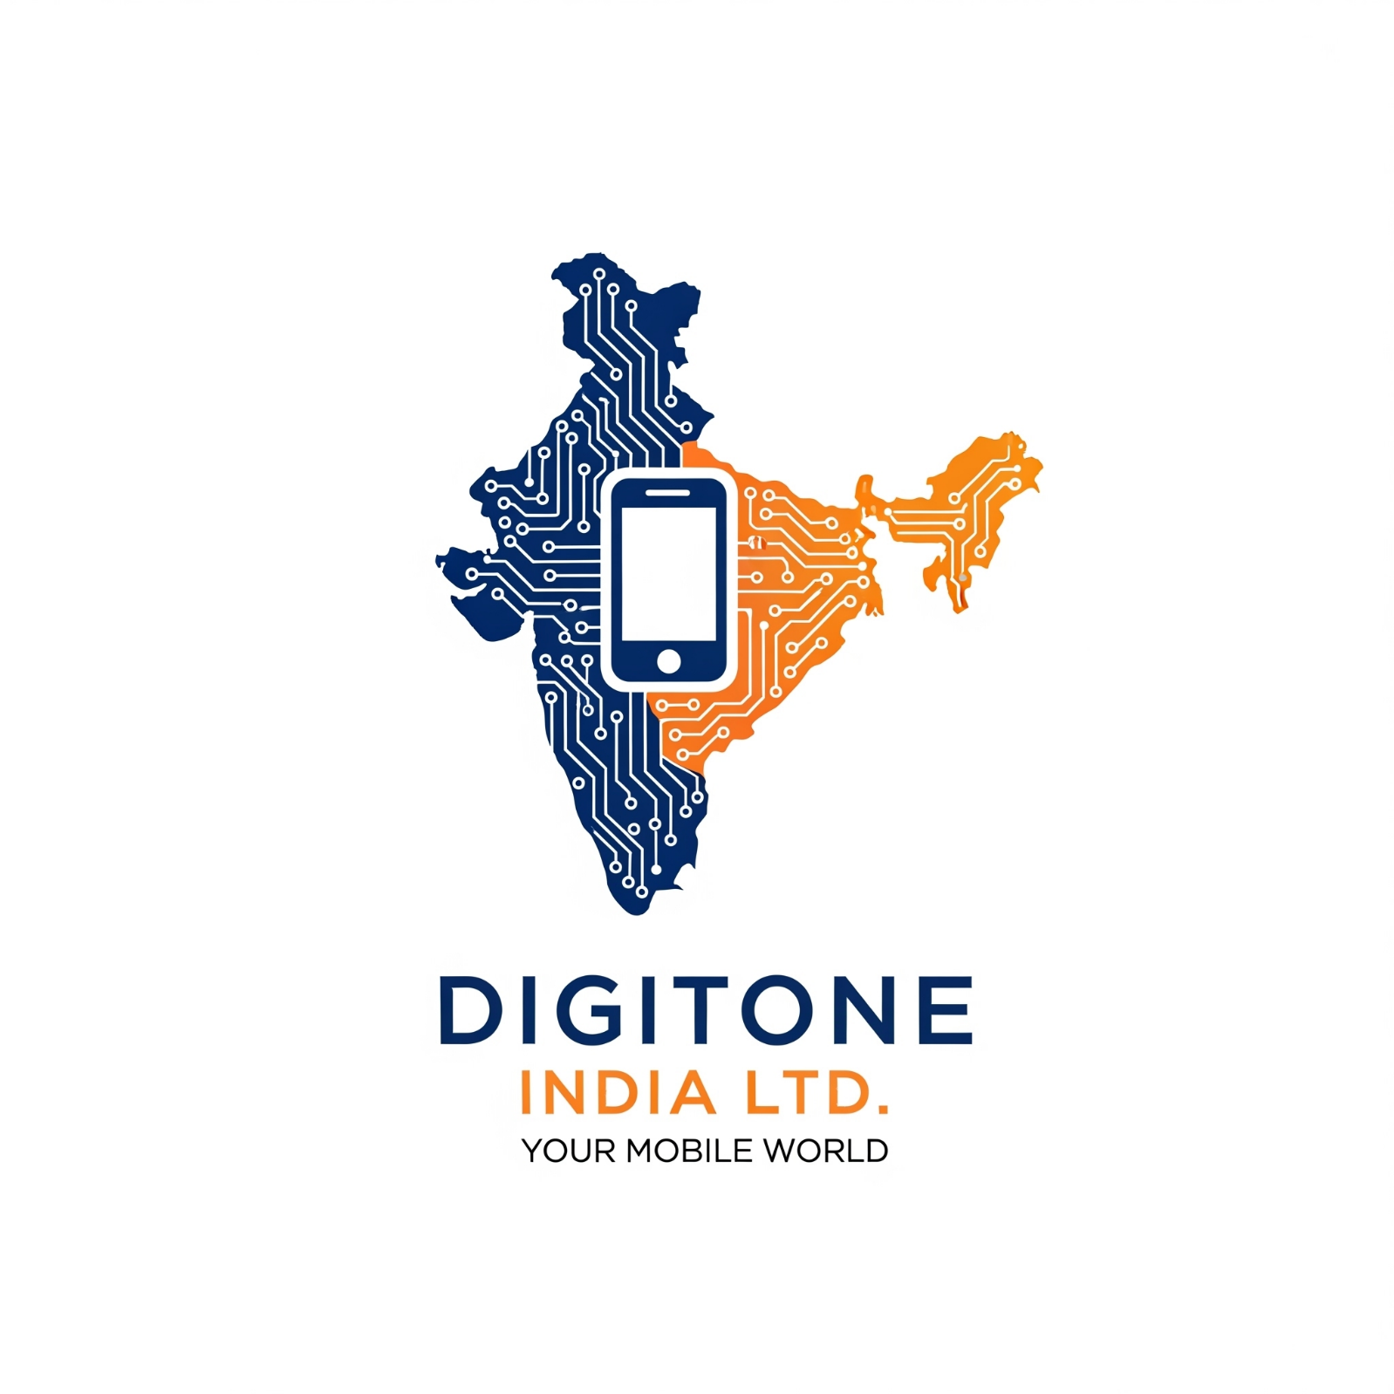

# **Introduction**

This Report compares the sales performance of **Zeniva Z12 Ultra**, **Nexora Edge 5G**, **Digitone Phantom 11,** for the **Q2** and **Q1 2025**. The objective is to **analyse sales trends**, **identify top-performing products** and provide **recommendations for improving sales strategies**.

# **Sales Data**

|  |  |  |  |
| --- | --- | --- | --- |
| Product Name | Q1 Sales (₹) | Q2 Sales (₹) | % Change |
| Zeniva Z12 Ultra | 872029.65 | 1046435.58 | +20.00 |
| Nexora Edge 5G | 1308044.47 | 1133638.54 | -13.33 |
| Digitone Phantom 11 | 697623.72 | 828428.17 | 18.75 |

**Figure A: Quarterly Comparison by Product**

# **Analysis**

* The **Nexora Edge 5G** had the highest total sales, while the **Zeniva Z12 Ultra** showed the most growth at 20%.
* The **Nexora Edge 5G** showed the most decline at -13.33%.

# **Recommendations**

* Increase marketing efforts for underperforming products.
* Focus on high-performing products for expansion (**Zeniva Z12 Ultra).**
* Investigate reasons for sales decline in **Nexora Edge 5G.**